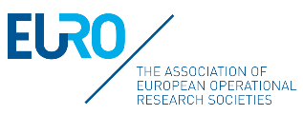 | 2022 EURO PhD Summer School on MCDA/MCDM
Please fill this form with your information and send it back by email at mcdmss21@bilkent.edu.tr
A) Personal information (Please type or print in CAPITAL LETTERS, * required information)
* Title: ___Mr ___Ms ___ Other (specify): _____________
* First name: _____________________________________________________________________
* Last name: _____________________________________________________________________
* Nationality: _____________________________________________________________________
* English proficiency level (TOEFL, IELTS, other):
* Institution:
* Institution web page:
Postal address:
Postal code: ____________ City: _____________________ * Country:
* Tel: (country code - area code - tel no.)
* E-mail address:
B) Research interests:
Title of your PhD:

Name of your advisor:
Select your research interests:
___ Multiattribute Utility/Value Theory ___ Outranking Methods
___ Preference Modelling ___ Group Decision Making
___ Multiobjective Optimization ___ MOCO
___ Evolutionary Multiobjective Optimization ___ AHP
___ Interactive Methods ___ Rough Sets
___ Conjoint Measurement ___ Social Choice Theory
___ Applications of MCDA/MCDM (specify the domain): ________________________________
___ Other (specify):_____________________________________________________________
C) Motivation to attend the Summer School:
What are your main motivations to attend the Summer School?

